Protocol for making fossil cradles
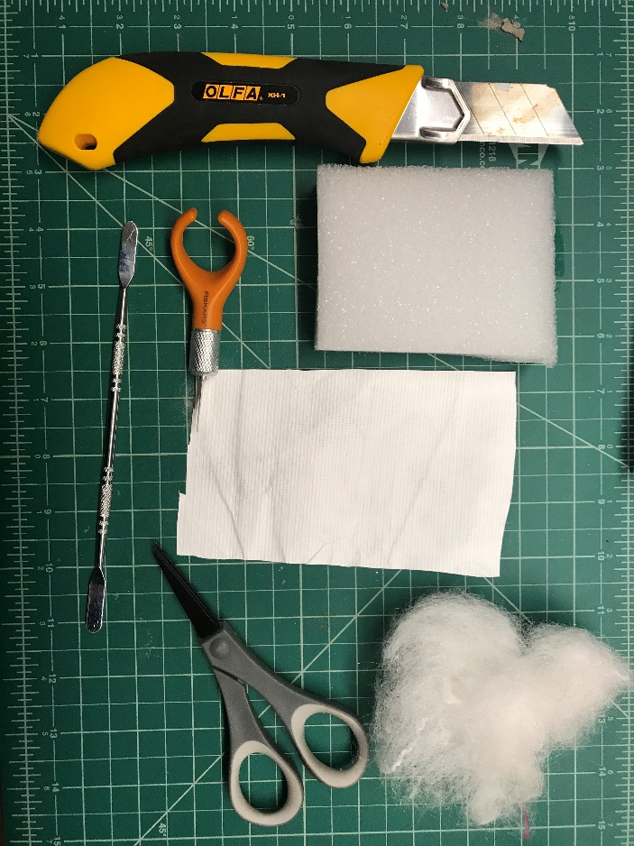
This describes a method for permanent storage of fossil specimens. Traditionally applied to vertebrate fossils, cradles can also be utilized to support fragile paleobotanical specimens. This technique was applied to fossils from the Red Hot Truck Stop for repository in the Smithsonian.
- Supplies needed (*quantity depends on number of specimens)
H
G
E
F
D
C
A
B
 | material | link to purchase
A | Ethafoam* 24x108x1” | http://www.conservationresources.com/Main/section_10/section10_16.htm
B | Tyvek* | https://www.amazon.com/Kitemaking-Material-Durable-Lightweight-Breathable/dp/B00G28H9QW/ref=sr_1_3?ie=UTF8&qid=1533918961&sr=8-3&keywords=tyvek
C | Batting* | https://www.amazon.com/Air-Lite-520-18-Eco-Friendly/dp/B000OP624O/ref=sr_1_4?s=arts-crafts&ie=UTF8&qid=1533919024&sr=1-4&keywords=loose+batting
D | utility knife | https://www.amazon.com/OLFA-1071858-Fiberglass-Rubber-Utility/dp/B000N7EU1K/ref=sr_1_1?ie=UTF8&qid=1538082154&sr=8-1&keywords=Olfa+xh-1
E | exacto knife | https://www.amazon.com/Fiskars-163050-1001-Fingertip-Craft-Orange/dp/B001480O26/ref=sr_1_23?s=arts-crafts&ie=UTF8&qid=1538077340&sr=1-23&keywords=exacto%2Bknife
 | 100 replacement blades | http://a.co/d/6TCyPKM
F | metal spatula | https://www.amazon.com/Delcast-Stainless-Spatula-Opening-Smartphone/dp/B0741QCSBG/ref=sr_1_25?s=hi&ie=UTF8&qid=1538081868&sr=1-25&keywords=metal+spatula+scraper
G | detail scissors | https://www.amazon.com/Fiskars-154110-1001-Non-stick-Titanium-Softgrip/dp/B005NAGBC8/ref=sr_1_3?ie=UTF8&qid=1538136327&sr=8-3&keywords=small+scissors
H | cutting mat | https://www.amazon.com/Alvin-GBM0812-Professional-Self-Healing-Convenient/dp/B0015AOIYI/ref=sr_1_20?s=arts-crafts&ie=UTF8&qid=1538077340&sr=1-20&keywords=exacto%2Bknife&th=1
 | aluminum meter stick | https://www.amazon.com/Starrett-MS-2-Aluminum-Straight-Length/dp/B004RI53JE/ref=sr_1_4?ie=UTF8&qid=1538080601&sr=8-4&keywords=metal+yardstick
 | archival paper | https://www.amazon.com/Archival-Methods-98002-White-Sheets/dp/B0030NY3PW/ref=sr_1_5?ie=UTF8&qid=1538078286&sr=8-5&keywords=archival+paper

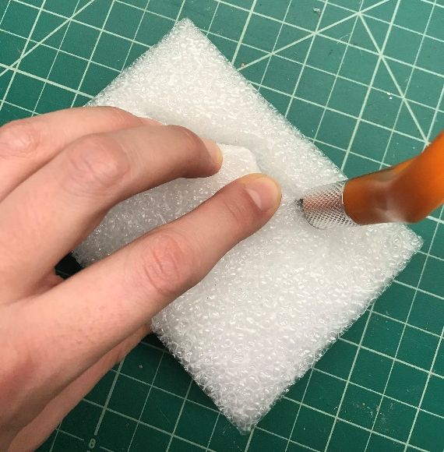
- To get started, use the cutting mat, meter stick, and utility knife to cut Ethafoam to sizes needed to fit inside the specimen boxes.

- Carefully place the specimen on top of the cut foam rectangle. Using the exacto knife, trace around the fossil, outlining it closely, but not too close. In this step, you are scoring the place you will cut out to create the cradle, so you will want the fossil to be able to fit within this outline.
Step 4

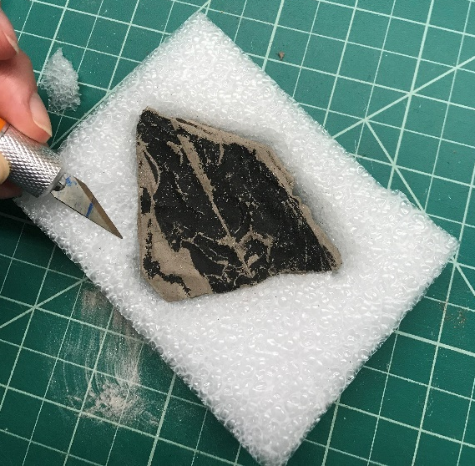
- Next, move the specimen to a safe place and continue to cut out the cavity in the foam, following the outline created in step two. In this step, you will cut all the way through to the other side of the foam so that you end up removing the entire piece.

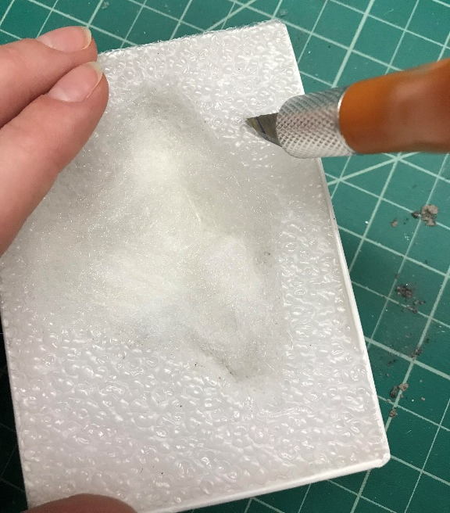
- Once the center piece is removed, discard it. Place the fossil into the cavity to ensure that it will fit and do any trimming of the foam if needed. The fit should not be so close that it has to be jammed in and could break the rock, and it should not be too big that it has lots of extra space around it to move around. Next, strategically cut a shallow divet in the foam for a finger hold, if needed. This allows an entry point for removing the fossil from cradle later if the specimen needs it.
Step 5

- The foam is ready to go into the specimen box. Add in a layer of batting in the bottom, inside the new cavity. Keep in mind you should add foam according to the thickness of the rock. You don’t want to much. Next, score around the entire edge of the cavity with the exacto knife, including around the edge of your finger hold made in step 5.
Step 6

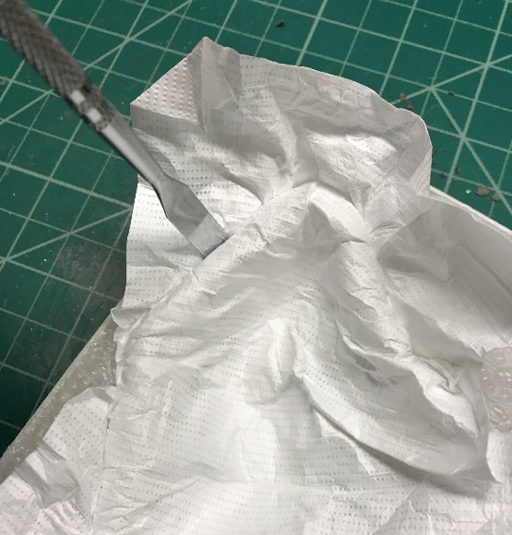
- Cut a rectangle of the Tyvek, usually needs to be a bit bigger than your foam/specimen box to work. Crumple it up into a ball to soften it. You want the smooth side facing up. Place it into the cavity, molding it into the shape and up along the walls. While supporting the Tyvek into the cavity with one hand so it stays flush inside, use the metal spatula to start to tuck the Tyvek on the edges into the prescored slit from step 6. Continue all the way around the specimen so the Tyvek is secured.
Step 7

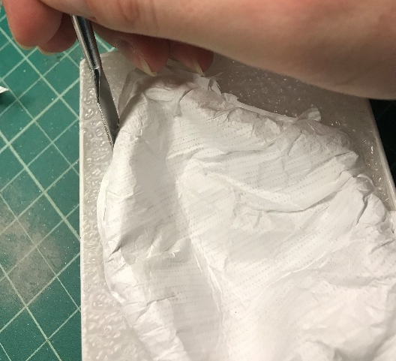
- Now is a good time to make sure that the specimen has a good fit in the cradle, so put the fossil in to test it out. If needed you can remove the Tyvek to add or remove batting. Use the detail scissors to trim any excess Tyvek that is sticking out and discard it.
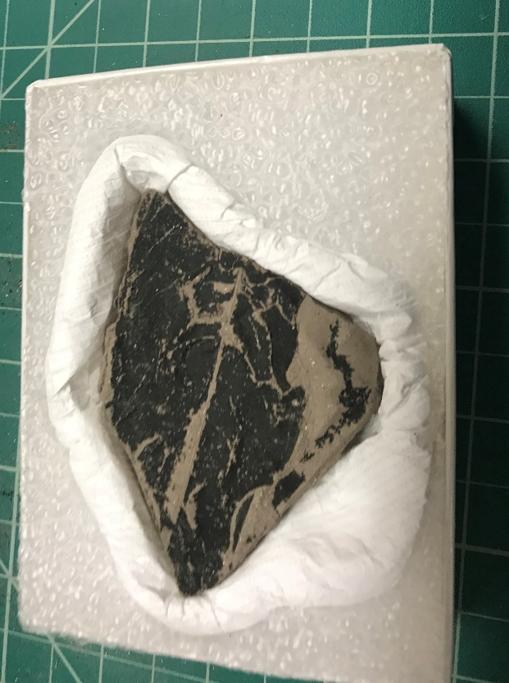
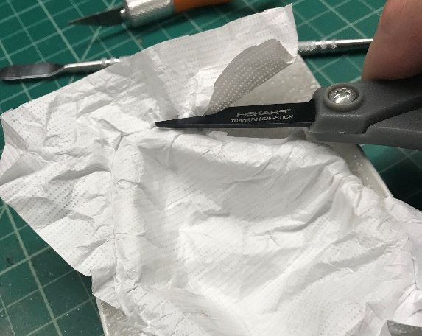
Step 9
Step 8
- Go back around the edge with the metal spatula to clean up the seam and stuff any remaining Tyvek in snugly to the slit

- Put the fossil into the cavity and you are done! Print your specimen labels on archival paper and use a map pin to attach the label to the foam surrounding the specimen.

